**14.Math for Game Developers - Mouse Control (Euler Angles)**

**17.Math for Game Developers - Bullet Whizzes (Projections)**

**19.Math for Game Developers - Character Movement 8**

**21.Math for Game Developers - Rotating Characters (Matrix Rotation)**

**24.Math for Game Developers - Updated Bullet Collisions (Coordinate Systems)**

last step - why multiply inverse matrix to the end of equation, not in the beginning

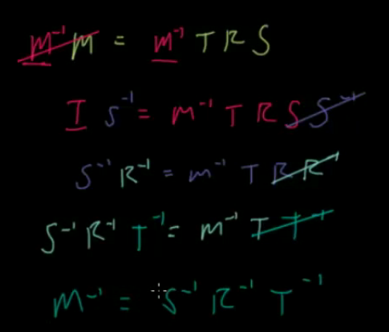

31. Math for Game Developers - Rotation Quaternions

38. Math for Game Developers - The Camera View Transform Matrix

I cannot understand why 1,2,3 col of Matrix can represent the rotation of x,y,z. like below:

52 Math for Game Developers - Normal Maps

I can’t understand the construction of matrix which convert texture coordinate to local coordinate

mat3 mTBN = mat3(vecFragmentTangent, vecFragmentBitangent, vecFragmentNormal);

why last one is vecFragmentNormal.

Why normal map can produce bump effect?

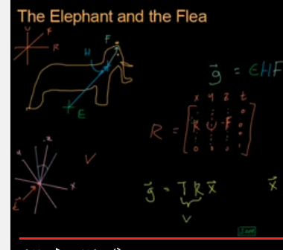

43. Math for Game Developers - Perspective Matrix Part 2

Project object from near and far plane to a cube area.

I cannot understand the ratio of width over height.